**Assignment 1.2**

**1. What should be the output of the following Script?**

v <- c( 2,5.5,6)

t <- c(8, 3, 4)

print(v%/%t)

**Solution:**

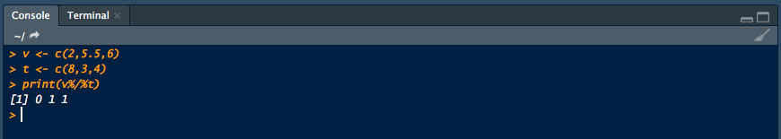

**2. You have 25 excel files with names as xx_1.xlsx, xx_2.xlsx,........xx_25.xlsx in a dir.**

Write a program to extract the contents of each excel sheet and make it one df.

**Answer:**